Datum i vreme

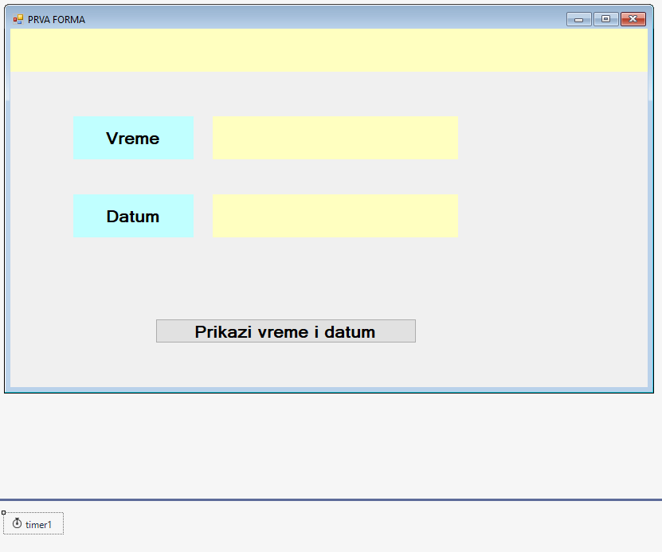

**namespace Vreme__datum**

**{**

**public partial class Form1 : Form**

**{**

**public Form1()//KLASA Form1**

**{**

**InitializeComponent();**

**}**

**private void btnPrikaz_Click(object sender, EventArgs e)//lblVreme,**

**{**

**DateTime t = DateTime.Now;**

**//lblVreme.Text = t.ToString();//probajte prvo ovo , a posle posebno sate, minute..**

**//lblVreme.Text = t.Hour.ToString() + ":" + t.Minute.ToString() + ":" + t.Second.ToString();//**

**lblVreme.Text = t.Hour.ToString("00:") + t.Minute.ToString("00:") + t.Second.ToString("00");//prikaz sa dve cifre i dve tacke**

**lblDatum.Text = t.Day.ToString("00 / ") + t.Month.ToString("00 / ") + t.Year.ToString("00 ");**

**}**

**private void timer1_Tick(object sender, EventArgs e)//lblVremeS (Properties-> Dock->Top)**

**{**

**DateTime t = DateTime.Now;**

**lblVremeS.Text = t.Hour.ToString("00:") + t.Minute.ToString("00:") + t.Second.ToString("00");//prikaz vremena i sekundi koje se menjaju u tajmeru**

**Text = t.Hour.ToString("00:") + t.Minute.ToString("00:") + t.Second.ToString("00");//prikaz vremena u naslovu Form1**

**//this.Text = t.Hour.ToString("00:") + t.Minute.ToString("00:") + t.Second.ToString("00");//prikaz vremena u naslovu Form1,na drugi nacin } }}**